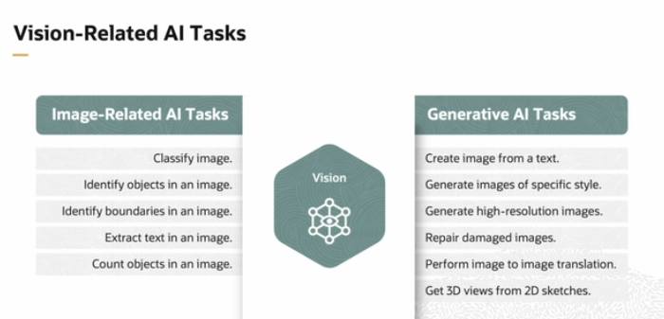

As in the previous part we have discussed about the language, audio speech related task , so now we will discuss about the **Vision related task.**

So now basically the main thing to understand in every domain task is that first we give input Now the type of input is depends on the task , and then on the basis of the task it provide the output let say if you want to classify image you provide input as img and get output in text form or etc and similarly if you want to generate img so most probably you will provide the input in text and get output in form of img. So it means the type of input and output depend on the task.

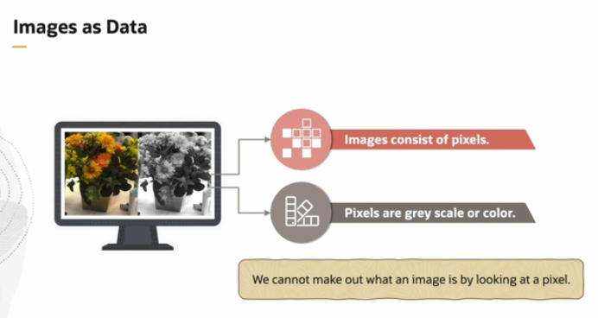

* Now basically the Images consist of many pixels.
* Pixels can be colorful or grey scale (black n white image).
* Now like text as data and audio as data may toh hum Data ko break krletay hain But agar Images ko break kreinga pixels may toh it is can’t able to identify or in other words we can also say that Image as **Data is not in sequential data** so that’s why we cannot apply those Architecture which we have used before like: RNN, LSTM, Transforemer etc. so now what to do ? Now in the below expalanation you will understand that how to handle this task.

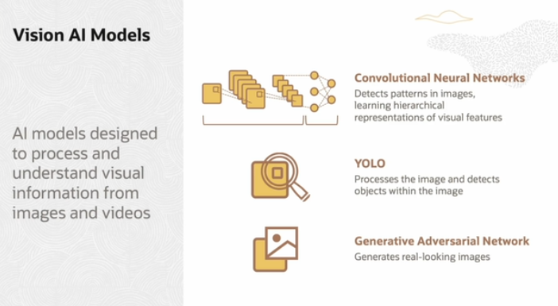

Now above are the Architectures that can process Images.

1. **Convolutional Neural Networks (CNNs):**

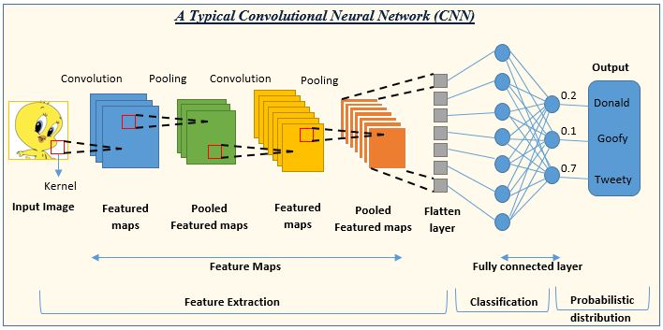

Right now srf ek structure ka liya pic paste ki hai baki Abhi in depth explanation nhi hai.

* **What It Does**: CNNs are deep learning models designed to detect **patterns** in images, learning **hierarchical** representations of visual features. They start by detecting low-level features like edges and gradually progress to more complex objects.
* **Use Case**: **Image Classification**
  + **Example**: **Google Photos** uses CNNs to automatically categorize images (e.g., identifying faces, objects, or scenes).
* **Strengths**:
  + **Good for Pattern Detection**: Excellent at understanding spatial hierarchies and detecting patterns like edges, textures, and objects in images.
  + **Highly Accurate**: CNNs achieve high accuracy on many vision tasks like image classification, facial recognition, and medical image analysis.
* **Limitations/Complexity**:
  + **Large Datasets Required**: CNNs need a lot of labeled training data to generalize well, especially for complex tasks. Without sufficient data, they may overfit or fail to learn important patterns.
  + **Computationally Expensive**: CNNs involve a lot of mathematical operations, especially in deep layers, which require powerful GPUs and long training times.
  + **Limited Global Context**: CNNs can struggle to understand the **global context** of an image, as they primarily focus on local features. Isi lia attention-based models, like Transformers, are sometimes more effective for tasks requiring a broader view of the entire image.
* Now basically in simple terms, CNN have a layered architecture so when we first input the Image , it only detect it from upper-level like shape of image , some color . then when Image goes to other layer they gradually go in it depth and detect some complex object and after passing through some other layers we will finally Got the output. But iska fallback yehi haka yeh Image kay global context ko nhi understand krskti bcuz primarily iski attention context pa nhi hoti blkay jo local higher level features hotay hain unko detect krta hai then isi tarah wo next layer ko pass krdeta hai due to that wo jo ek global overview hota hai wo nhi grab krskta.

1. **YOLO (You Only Look Once):**

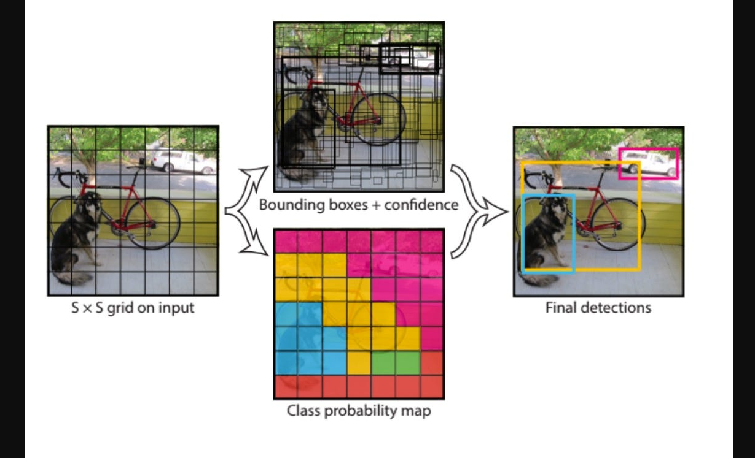

Now basically yeh jo YOLO hai yeh layered architecture pa base nhi krta , yeh ek hi dafa may or we can say in single hit image ko detect krleta hai by dividing it into Grids , Like in above pic jasay ki ek Image input hui usne uski griding krli then phr jo grid boxes hotay hain wo jasay jasay object detect krtay hain uskay around ek bounding create krletay hain or then phr it checks the probability of objects , mtlb kay konsa object aa skta hai and then phr wo final detection deta hai. But these are so fast isi lia jaha par instantly or we can fast detection krni hoti hai waha yeh architecture use hota hai.

* **What It Does**: YOLO is a real-time object detection model that processes an image **once** to detect multiple objects simultaneously. It divides an image into grids and detects objects within those grids.
* **Use Case**: **Real-Time Object Detection**
  + **Example**: **Self-driving cars** use YOLO to detect pedestrians, other vehicles, road signs, and obstacles while the vehicle is moving.
* **Strengths**:
  + **Real-Time Speed**: YOLO is designed to be extremely fast and is capable of running in real-time, making it ideal for applications like **surveillance** and **autonomous driving**.
  + **Single Pass**: Unlike other object detection models (e.g., R-CNN), YOLO processes the image in a single pass, which makes it more efficient.
* **Limitations/Complexity**:
  + **Struggles with Small Objects**: YOLO can miss small objects in complex images because it processes the entire image at once, and the grid-based structure can struggle to detect very small or distant objects.
  + **Lower Precision**: While YOLO is fast, it sacrifices some precision and accuracy compared to models that process images more slowly and thoroughly. For instance, models like Faster R-CNN might achieve higher accuracy at the cost of speed.
  + **Limited Detection of Overlapping Objects**: YOLO can have difficulty detecting multiple overlapping objects due to the grid-based structure, which might assign one object to multiple grid cells.

1. **Generative Adversarial Networks (GANs):**



Now mainly there are two players in GAN that are Discriminator and Generator. Ab jo **Discriminator** hai wo as ek police man or detector ka role perform kr rha hai kay it first takes final output or we can say the real Image and then on the basis of that inputted real Image it is detecting the output of **Generator.** AB yaha main question yeh haka Why real image is given to discriminator two times ? So iska answer yeh haka showing the real image two times (or multiple times during training) is essential for the discriminator to **learn** the patterns of real images and continually **improve** its classification ability. This competition between the **generator** and **discriminator** is what makes GANs so effective in generating realistic-looking images.

* **What It Does**: GANs consist of two competing networks: a **generator** that creates new data (e.g., images) and a **discriminator** that evaluates whether the generated data is real or fake. Over time, the generator learns to create highly realistic images.
* **Use Case**: **Image Generation**
  + **Example**: **Deepfakes** use GANs to generate fake but realistic human faces, often used for creating manipulated videos or images.
* **Strengths**:
  + **Highly Realistic Generation**: GANs are incredibly good at creating **realistic images**, such as generating high-quality human faces, landscapes, or art. They are also used in applications like **super-resolution** (increasing image quality) and **image-to-image translation** (e.g., turning sketches into realistic images).
  + **Creative Use Cases**: GANs are used in areas like **artificial creativity**—creating new artworks, fashion designs, or even generating new game assets.
* **Limitations/Complexity**:
  + **Difficult to Train**: GANs are notoriously **hard to train**. The balance between the generator and discriminator can be delicate. If one model (discriminator or generator) becomes too strong, the training process can collapse, and the generator might start producing poor-quality images.
  + **Mode Collapse**: GANs can suffer from **mode collapse**, where the generator produces very limited variations of images, even when diverse outputs are desired. This limits the creativity and diversity of the generated images.
  + **Computationally Intensive**: Training GANs often requires powerful hardware and significant amounts of data. Generating realistic high-quality images is a resource-intensive task, especially for large-scale GANs.

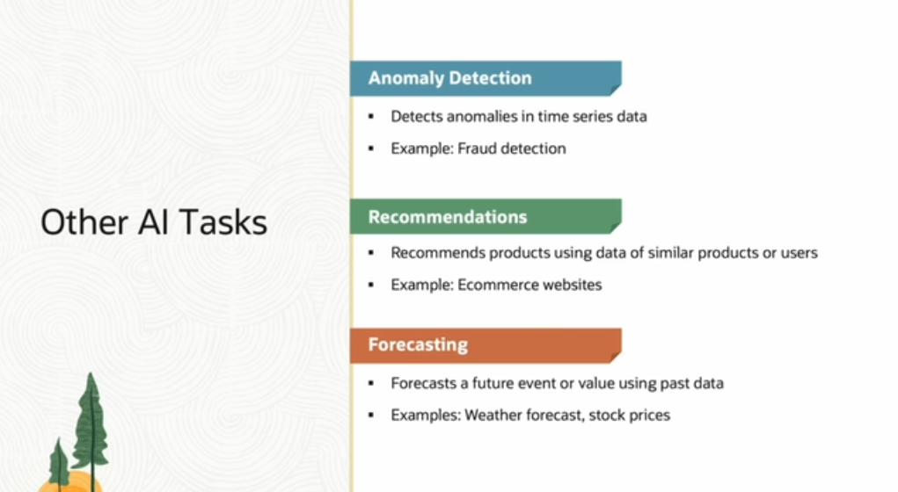

Some confusions:

1. Model VS Architecture

**1. Architecture:**

* **Definition**: The **architecture** of a deep learning system refers to the **overall design and structure** of the neural network. It's essentially the blueprint or framework that defines how different layers of the network are organized, how data flows through it, and how computations are carried out.
* **Key Aspects** of Architecture:
  + The **type of layers** (e.g., convolutional layers, recurrent layers, fully connected layers).
  + The **number of layers** (deep networks have more layers).
  + The **connections** between layers (e.g., sequential, skip connections, residual connections).
  + The **activation functions** used (e.g., ReLU, Sigmoid, Tanh).
* **Examples of Architectures**:
  + **Convolutional Neural Network (CNN)**: An architecture designed for image processing tasks, composed of convolutional layers that detect spatial patterns like edges, textures, etc.
  + **Recurrent Neural Network (RNN)**: An architecture designed for sequential data (like time series or language), with feedback loops that allow the network to "remember" previous steps.
  + **Transformer Architecture**: Used for NLP tasks like translation or text generation, employing self-attention mechanisms to process input sequences in parallel.
* **Analogy**: Think of an architecture as the **blueprint** for a building—it defines what the building will look like, how its floors are connected, and how the rooms are laid out. But it doesn't specify the exact materials used or how the building performs in practice.

**2. Model:**

* **Definition**: A **model** refers to the **specific instance** of a neural network that has been **trained** on data. It includes not just the architecture but also the **weights** and **parameters** that have been learned during the training process.
* **Key Aspects of a Model**:
  + The **trained parameters** (weights and biases) that are learned during the training process by adjusting based on the data.
  + The model’s **performance metrics** (e.g., accuracy, loss) after training on a specific task.
  + The model can be **used for inference**—making predictions or performing tasks based on new input data.
* **Examples of Models**:
  + **ResNet-50**: A trained model based on the ResNet architecture, specifically containing 50 layers. It is widely used for image classification tasks.
  + **GPT-3**: A trained language model based on the **Transformer architecture** that can generate human-like text.
  + **BERT**: Another model based on the **Transformer architecture** trained specifically for natural language understanding tasks.
* **Analogy**: Think of a model as the **finished building**, where materials (weights and biases) have been added, and it’s ready to be used. It’s the trained, functioning version of the network that can now perform a task based on what it has learned.

Its mean basically jo Architecture hota hai wo way of creating Model hota hai, kay let say we are creating an model for Image detection so now we have three architecture such as CNN, YOLO, GAN . is am right or wrong ?

Yes, you're absolutely **right**! You're on point with your understanding. Let's clarify it a bit more to make sure everything is crystal clear.

**Here's what you're saying, broken down:**

* **Architecture** is the **design** or **blueprint** that defines how a model is built and how it processes data.
* If you're building a model for **image detection**, you have several **architectures** to choose from based on the task and the type of results you want.

So in your case:

1. **CNN (Convolutional Neural Network)**:
   * This architecture is designed to recognize **patterns** in images (like edges, textures) and is great for tasks like **image classification** (e.g., detecting objects like cats, dogs, etc.).
2. **YOLO (You Only Look Once)**:
   * This architecture is specifically designed for **real-time object detection**. It can detect and locate multiple objects in an image at once.
3. **GAN (Generative Adversarial Network)**:
   * While GANs are typically used to **generate new images**, they can also be trained to create images that match certain properties, or they could potentially be adapted to detect objects in creative ways.

**Time Series:**

A **time series** is a sequence of data points collected or recorded at specific time intervals. It represents how a certain variable or set of variables **change over time**. Each observation in a time series has a timestamp, making it unique from regular data, where the order of data points usually doesn't matter.

**Key Features of a Time Series:**

1. **Temporal Order**: The order of data points matters because each point is dependent on the previous one in some way.
2. **Time Intervals**: The data is recorded at consistent intervals (e.g., every minute, hour, day, month, etc.).
3. **Dependence on Time**: The variable's value depends on its past values, making time an important feature for prediction.

**Real-World Examples of Time Series:**

* **Stock Prices**: A record of stock prices over time (daily closing prices).
* **Weather Data**: Temperature measurements recorded every hour, day, or month.
* **Sales Data**: Monthly sales revenue of a company.
* **Sensor Data**: Heart rate readings recorded every second from a fitness tracker.